:Given a bank customer, build a neural network-based

Classifier that can determine whether they will leave or not in the next 6 months

- Artificial Neural Network (ANN)

ANN is a computational model inspired by the human brain, consisting

Of interconnected nodes (neurons) that learn patterns in data for tasks

Like classification and prediction.

- Keras

Keras is a high-level neural network library in Python, built on top of

TensorFlow, that simplifies building and training deep learning models.

- TensorFlow

TensorFlow is an open-source machine learning framework that

Supports building, training, and deploying large-scale machine learning

And deep learning models.

- Normalization

Normalization is the process of scaling data to a standard range (usually

0 to 1) to ensure each feature contributes equally to model performance.

- Confusion Matrix

A confusion matrix is a table that shows the performance of a

Classification model by comparing actual vs. Predicted values for each

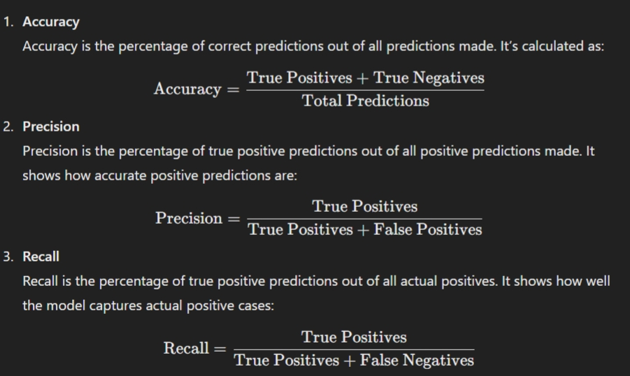
Class, helping to evaluate accuracy, precision, and recall.

